# Introduction

## Purpose

This software design document describes the architecture and system design of PeggleClone405.

## Scope

The goal of this project is to provide the Human-Computer Interaction lab at the University of Saskatchewan with a game that has skill based discrete rewards in which the gratuity can be scaled to observe players reactions for research purposes.

## Overview

This project is being done by Evan Snook for CMPT 405 at the University of Saskatchewan under supervision of Regan Mandryk.

# System Overview

PeggleClone405 is built using Unity3D as a fully functioning game for a personal computer.

# System Architecture

## Architectural design

The System consists of independent components that can exist within Unity themselves with no further modification. They may have behaviours so long as another component is not needed. When an interaction needs to take place, the component sends a message to the game_manager and it is then dealt with in the appropriate manner.

## Decomposition Description

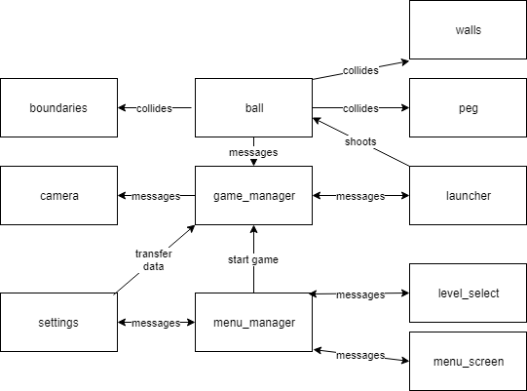

## Design rationale

Due to the nature of Unity3D, I decided that this would be the best architecture for the game as it would lower coupling to make the components very manageable.

# Component Design

Walls

+Transform

+SpriteRenderer

+Collider2D

Peg

+Transform

+SpriteRenderer

+Collider2D

Launcher

+Transform

+SpriteRenderer

+shoot

+follow_mouse

+raycast_trajectory

Ball

+Transform

+SpriteRenderer

+Rigidbody2D

+Collider2D

+OnCollisionEnter2D

Boundaries

+Transform

+SpriteRenderer

+Collider2d

+OnCollisionExit2D

Camera

+Transform

+Camera

+zoom

Game_manager

+reset_fire

+game_over

+game_won

+level_rules

Menu_manager

+switch_scenes

Level_select

+start_level

+see_completed

Menu_screen

+show_level_select

+show_settings

+new_game

Settings

+camera_zoom

+slow_motion

+visual_effects

+volume

# Human Interface Design

## Overview of User Interface

The user loads into the main menu from which they may start a game, select a level, or modify settings. The settings will determine the win scenario for a level. Once the user loads into a level they play the level until they win or lose. They then get the option to continue to the next level, or return to the menu.

## Screen Images and descriptions

The main menu gives the player 4 option, each of which brings them to a new screen

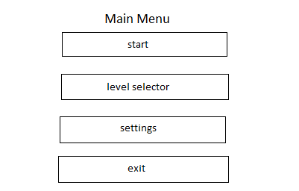

The level selector allows the player to navigate through the various levels, go back to the main menu, or start a game from a selected level.

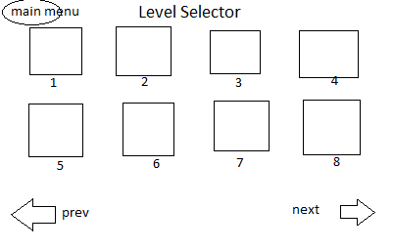

The settings screen allows the player to modify the settings for the rewards using sliders, and then return to the main menu

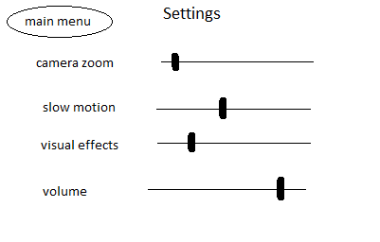

The ingame screen is where the player plays the game. They can exit to the menu at any time

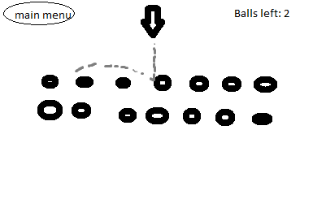

Gameover is the popup when you lose/win a game and need to chose what to do next